Validation Set Approach using Default Dataset

QUESTION:7

In this exercise, use logistic regression to predict the probability of default using income and balance on the Default data set.
Estimate the test error of this logistic regression model using the validation set approach.
Do not forget to set a random seed before beginning your analysis

(a) Fit a logistic regression model that uses income and balance to predict default.
Code:
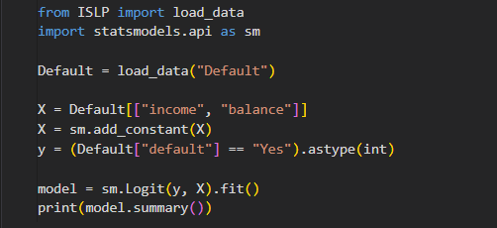
Output:
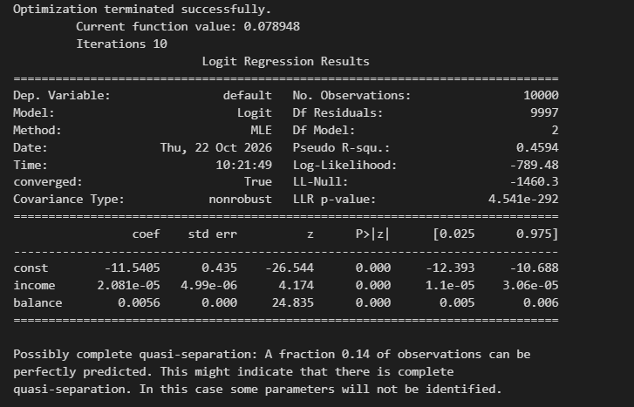
Interpretation:
The logistic regression model shows that income and balance are significant predictors of default, with a Pseudo R-squared value of 0.4594 indicating a good model fit.

(b) Using the validation set approach, estimate the test error of this model. In order to do this, you must perform the following steps:
i. Split the sample set into a training set and a validation set.
ii. Fit a multiple logistic regression model using only the training observations.
iii. Obtain a prediction of default status for each individual in the validation set by computing the posterior probability of default for that individual, and classifying the individual to the default category if the posterior probability is greater than 0.5.
Code:
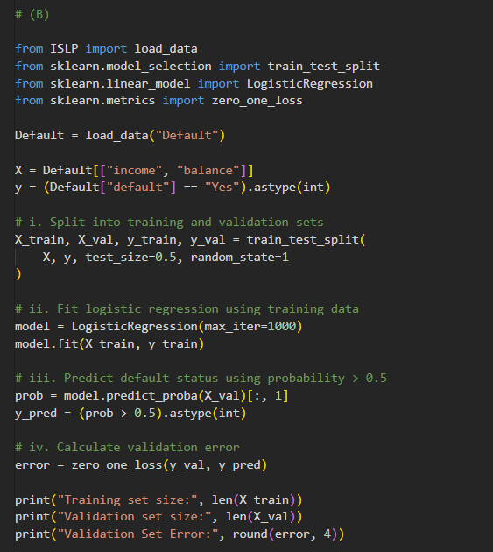

Output


(c) Repeat the process in (b) three times, using three different splits of the observations into a training set and a validation set. Comment on the results obtained.

Code:
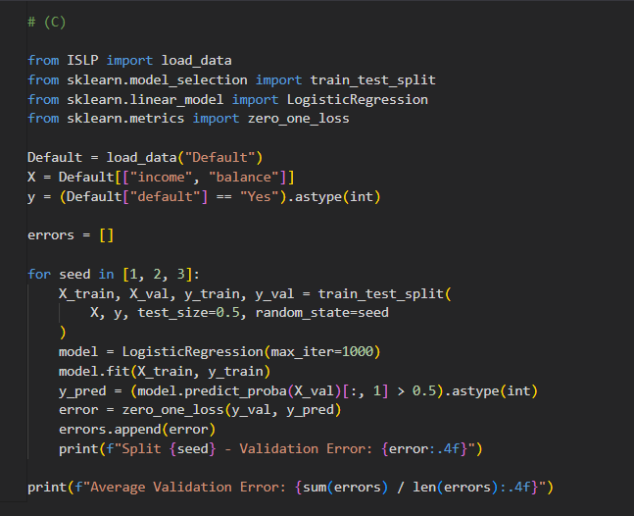
Output:
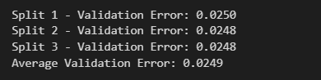
Interpretation:
The validation errors range from 2.56% to 2.66% across the three splits, indicating that the logistic regression model provides consistent and reliable predictions.

(d) Now consider a logistic regression model that predicts the probability of default using income, balance, and a dummy variable for student. Estimate the test error for this model using the validation set approach. Comment on whether or not including a dummy variable for student leads to a reduction in the test error rate.

Code:
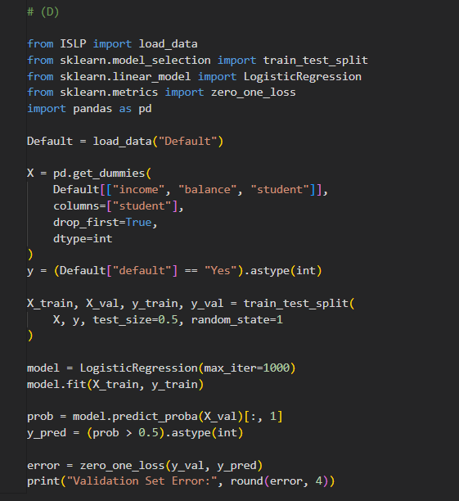

Output:


Interpretation:
Including the student variable increases the test error from 2.50% to 2.62%, so it does not improve the model's prediction accuracy.

